EX NO : 4  DATE : 01-07-26 | DIMENSIONALITY REDUCTION TECHNIQUES: USING PCA

AIM:
Dimensionality Reduction using Principal Component Analysis (PCA)
PROBLEM STATEMENT:
Use the Iris Dataset available in Scikit-learn. The Iris dataset contains four features: Sepal Length, Sepal Width, Petal Length, and Petal Width. Reduce these four features into two principal components using PCA and visualize the transformed data.
TASKS:
1. Load the Iris dataset (It is available in the Scikit-learn library).
2. Display the first five records.
3. Standardize all features.
4. Apply PCA with 2 components.
5. Display the transformed dataset.
6. Find the explained variance ratio.
7. Calculate total variance retained.
8. Plot a scatter graph of PC1 versus PC2.
9. Compare dataset shape before and after PCA.
10. Write your observations.
CODE:
# Import Libraries
import pandas as pd
import matplotlib.pyplot as plt

from sklearn.datasets import load_iris
from sklearn.preprocessing import StandardScaler
from sklearn.decomposition import PCA

# 1. Load the Iris dataset
iris = load_iris()
X = iris.data
y = iris.target
df = pd.DataFrame(X, columns=iris.feature_names)

# 2. Display the first five records
print(df.head())

# 3. Standardize all features
scaler = StandardScaler()
X_scaled = scaler.fit_transform(X)

# 4. Apply PCA with 2 components
pca = PCA(n_components=2)
X_pca = pca.fit_transform(X_scaled)

# 5. Display the transformed dataset
pca_df = pd.DataFrame(X_pca, columns=["PC1", "PC2"])
print(pca_df)

# 6. Find the explained variance ratio
print(pca.explained_variance_ratio_)

# 7. Calculate total variance retained
total_variance = pca.explained_variance_ratio_.sum()
print("Total Variance Retained:", total_variance * 100)

# 9. Compare dataset shape before and after PCA
print("Original Shape:", X.shape)
print("Reduced Shape:", X_pca.shape)

# 8. Plot a scatter graph of PC1 versus PC2
plt.figure(figsize=(8, 6))

colors = ['red', 'green', 'blue']
for i in range(3):
plt.scatter(
X_pca[y == i, 0],
X_pca[y == i, 1],
color=colors[i],
label=iris.target_names[i]
)
plt.xlabel("Principal Component 1")
plt.ylabel("Principal Component 2")
plt.title("PCA of Iris Dataset")
plt.legend()
plt.grid(True)

plt.show()
OUTPUT:
2.
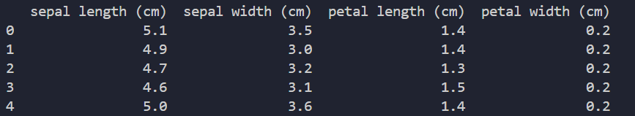
5.
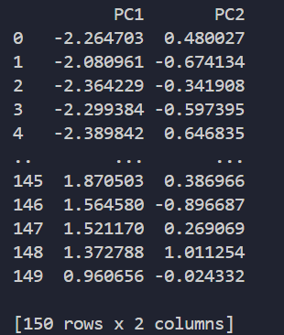

6.
7.
8.

9.
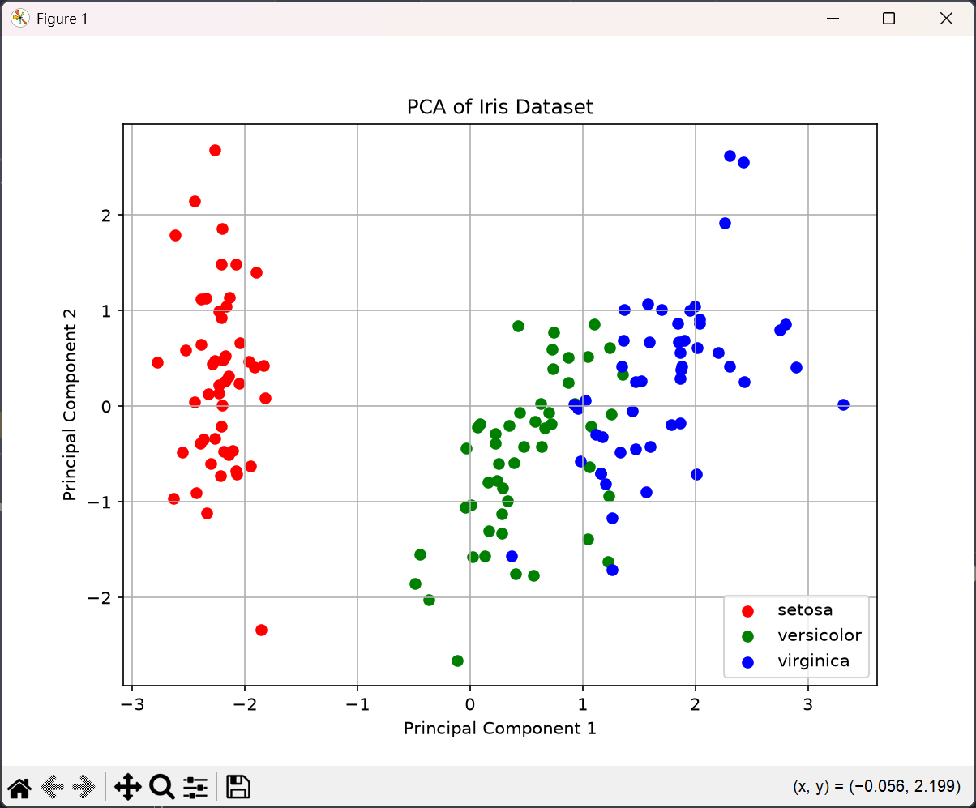
OBSERVATIONS:
• The four original features of the Iris dataset (sepal length, sepal width, petal length, petal width) were successfully standardized to have zero mean and unit variance before applying PCA.
• PCA reduced the dataset from 4 dimensions to 2 principal components (PC1 and PC2), simplifying the dataset while retaining most of the useful information.
• PC1 alone captures the majority of the variance in the data, while PC2 captures a smaller, independent portion of the remaining variance.
• Together, PC1 and PC2 retain a large percentage of the total variance in the original dataset, showing that most of the information can be represented in just two dimensions.
• The scatter plot of PC1 vs PC2 shows that the three Iris species (Setosa, Versicolor, and Virginica) form fairly distinct clusters, with Setosa clearly separated from the other two, confirming that PCA preserves the underlying class structure of the data even after dimensionality reduction.
• This demonstrates that PCA is an effective technique for reducing dimensionality while retaining most of the original information and enabling easy visualization of high-dimensional data.

